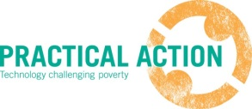
© Practical Action/Justine Williams
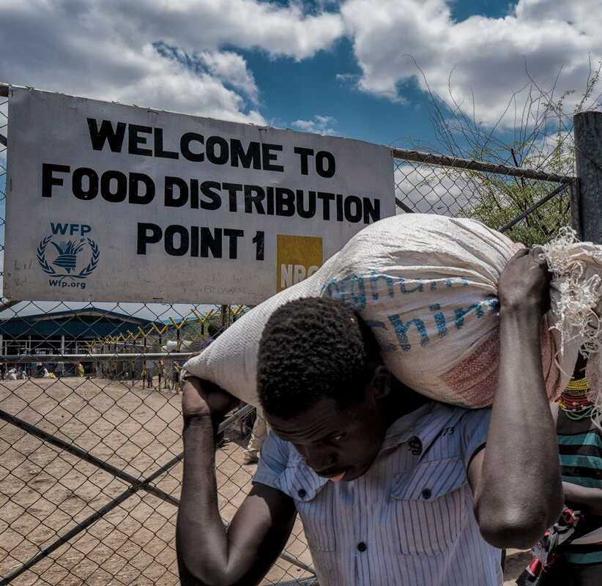

Technical Analyst - Humanitarian Energy
Practical Action UK
Recruitment Pack

Technical Analyst - Humanitarian Energy Role
Renewable Energy Access for Refugee Camps

Our Vision

Our vision is for a world where all people have access to the technologies that enable them to meet their basic needs and reach their potential, in a way that safeguards the planet today, and for future generations.
Technology is…
”The tools, and knowledge that people use for living”.

Our Beliefs

We believe that:
- Technology is a key enabler of human development; and that technological innovation has the power to propel us into a better world.
- All people should have access to, and a voice in, shaping the technologies that can improve their lives.
- A sustainable future for our planet requires a fundamental shift in the way technology is developed and used.

Our Mission

To develop and demonstrate practical, technology based solutions that enable women and men living in or vulnerable to poverty, to lead dignified lives. To partner with people whose lives are transformed by these efforts and with a range of other organisations, ensuring local ownership and that the solutions work in the longer term without us. To inspire change through the widespread adoption of sustainable technologies that work - socially, economically and environmentally, so that more people living in, or vulnerable to, poverty benefit from our learning.

Our Ambition and About Us

Our ambition is that by 2030 we will have transformed the way technology is used to improve the lives of people living in, or vulnerable to, poverty.

With 50 years of expertise, Practical Action has a strong heritage and track record of bringing communities and experts together to find practical, sustainable solutions to enable people to meet their needs, which work for both people and the planet. Technology features in everything we do. Working throughout Africa, Asia and Latin America, Practical Action improves the lives of around one million people every year through improved access to energy, sustainable agriculture, water, sanitation and waste management, and disaster risk reduction. We are a trusted partner of many communities, governments, development agencies and the private sector. We are uniquely placed as a knowledge broker with a breadth of capacities which enable us to capture and share knowledge in relevant ways for our diverse audiences. We are influential at national level where we work, and globally and considered a “go-to” agency by those seeking to improve energy access for people living in poverty.

Technical Analyst – Humanitarian Energy Role

ABOUT THE ROLE

This post is for a Humanitarian Energy Technical Analyst for Practical Action’s humanitarian energy projects, from October 2018 to December 2020. As a key technical delivery position, this role will develop technical analysis on access to sustainable energy for displaced persons. The role will require working with multiple sources of information and using economic, quantitative and qualitative methods to develop Practical Action’s energy and markets renewable energy interventions for refugees in Rwanda and tailored pieces of analysis in Jordan and Nepal. The role will be focused on developing and delivering the technical implementation of two projects led by Practical Action - the Renewable Energy for Refugees (RE4R) Project and Humanitarian Engineering and Energy for Displacement (HEED) projects. The role will provide analysis to inform and influence the sustainable energy policies, priorities and operations of donors, host governments, and national and international organisations. Regional oversight and technical support will be provided by the Practical Action UK office, East Africa office in Nairobi, and partner organisations in Jordan, Rwanda and globally.

Practical Action is managing the Renewable Energy for Refugees (RE4R) project in Rwanda and Jordan. This project is led by Practical Action and UNHCR to deliver renewable energy investments through innovative approaches in humanitarian settings, working directly with refugees and host communities in Kigeme, Nyabiheke and Gihembe refugee camps in Rwanda and with urban refugees in Irbid in Jordan. The project will provide access to affordable and sustainable sources of renewable energy, and improve the health, wellbeing and security of target populations. Practical Action are also partners on the Humanitarian Engineering and Energy for Displacement (HEED) project, which is an innovative project focused on the growing recognition of the need to improve access to energy, particularly renewable energy sources, for populations displaced by conflict and natural disasters. The focus of HEED is on the energy experiences of Congolese refugees living for protracted periods of time in three refugee camps in Rwanda (Nyabiheke, Gihembe and Kigeme) and internally displaced persons (IDPs) forced to leave their homes as a result of the earthquake in Nepal. These projects draw on Practical Action’s considerable existing experience in renewable energy programming in developing countries – working directly with communities to deliver the best energy services and products possible for local people. The projects are a part of a wider portfolio of humanitarian energy work which includes sustainable energy activities Kenya, Burkina Faso, Bangladesh and Uganda. The technical analyst role will support both of these projects to ensure technical quality of programming and undertaking quantitative analysis needed for the projects.

SCOPE

Title | Humanitarian Energy Technical Analyst
Reporting to | Head of Humanitarian Energy
Direct and Financial reports | None
Location | UK office: Rugby, Warwickshire
Duration | 2 years: October 2018 to December 2018
Travel | Expected approximately 12 weeks per annum
Additional Information | Grade B: Estimated around £33,000 to £38,000 a year.  Staff position at Practical Action – with a laptop and sharepoint access

ACCOUNTABILITIES

This role will involve the following core activities:

Delivers Technical Intervention Activities

- Leading the technical analysis in the UK for the (RE4R) project, including developing energy access intervention plans using qualitative, quantitative and markets data.
- Supporting the Humanitarian Engineering and Energy for Displacement (HEED) projects on technical analysis and research programme implementation.
- Managing analysis activities and research elements to support global humanitarian energy activities, including technical support to the Global Plan of Action on Sustainable Energy Solutions for Situations of Displacement.
- Delivering key technical support for the Rwanda, Nepal and Jordan elements of the projects.
- Ensuring Practical Action are capturing and using data and learning across the project to improve quality and to inform our growing portfolio on energy access in humanitarian contexts.
- Coordinates regular reviews of progress towards achieving project technical objectives and leads quality assurance work to ensure best practice and high-quality programming.
- Maintaining project documentation and contributing to the team priorities in the Practical Action Consulting, International Programmes and Rwanda country team’s work, as needed.

Rwanda Activities

- The Rwanda element of the RE4R and HEED projects has just undertaken a nine month detailed energy assessment. This role will support the Rwanda and UK teams in undertaking further energy access and markets analysis and data collection in the design phase of the Renewable Energy Intervention Plans for Refugees in the three Rwandan camps. The role will:
- Analyse quantitative data and qualitative, ethnographic and community-based information to understand the range of energy needs of refugees and host communities, and how the RE4R projects interventions address them.
- Research on market suppliers and energy financing mechanisms, data collection and analysis on companies and markets available to deliver the needs of the projects. Consultation with financial and markets stakeholders on the support mechanisms required for providing technical and financial assistance, and the steps which might be taken nationally and internationally.
- Quantitative energy analysis and modelling of key data on Rwandan refugee camps, including data gathering, analysing survey results, and key primary research for the RE4R and HEED projects as they develop.
- Work with Practical Action and partner teams to develop clear and detailed technical work plans taking into consideration the evolving technical approach to be defined by the Rwanda and UK teams. This will include integrating gender and protection needs and developing criteria for commercial tenders and bidding documents.

Nepal and Jordan Activities

- Technical analysis for data gathering and quality assurance for the interventions in Jordan for RE4R project, likely to include analysis of business models, results and energy access installed capacity, and monitoring and evaluation of the results of the Jordan work.
- Supports technical analysis on humanitarian energy needs in Nepal for the HEED project, including detailed quantitative analysis of energy access technologies such as solar water pumping, street lighting, and mini-grid solutions.
- Ensures flow of information and communication between country programmes and the project management team, especially with the Technical Programme lead.
Global and Knowledge Activities

- Supports Rwanda and UK humanitarian energy teams in: reviewing data gathering tools to ensure that information required for planning is appropriate. Combining economic demand and market analysis to arrive at combinations of solutions which best meet energy access goals.
- Compiles and analyses qualitative and quantitative data and produces reports on the RE4R project’s impact and beneficiary reach, taking gender into account.
- Collects data for the RE4R project’s monitoring, evaluation and learning (MEL) framework and uses tools for measuring the project’s impact and beneficiary reach: supports the MEL adviser on developing key data collection processes and indicators.
- Analyses climate change indicators and supports the development of greenhouse gas and reporting for the RE4R project.
- Supports technical inputs into to the Global Plan of Action on Sustainable Energy Solutions for Situations of Displacement, including technical work to support the data and evidence working group.
- Undertakes small pieces of business development and proposal writing for new humanitarian energy projects.
- Reviews, amends and improves data analysis tools to make them fit-for-purpose for future use by Practical Action and other organisations and supports co-designing a decision-making methodology for humanitarian energy feasibility assessments.
- Produces information on energy access business models and models of delivery for the project, including private sector, government and local NGO partners.
- Presents technical plans and information to a range of stakeholders and implementers to develop total energy access plans for the RE4R and HEED projects.

Leadership and People

- Provides technical analysis and intellectual scrutiny across the RE4R project.
- Supports the RE4R project’s Knowledge, Advocacy, M&E and Learning Working Group
- Contributes to overall planning, communications, effectiveness and team-working across humanitarian energy programming.
- Coordinates with colleagues in partner and donor organisations to align technical objectives and activities.
- Coordinates with Practical Action colleagues in technical and knowledge teams, and country offices to contribute to organisational learning.
- Supports Practical Action on the latest economic and assessment tools available, including quantitative methods of analysis. Provides briefings and updates for external partners on the potential use of these tools and how Practical Action can deliver high-quality analysis in partnership with leading humanitarian and energy institutions.

REQUIRED SKILLS AND EXPERIENCE

General Skills

- At least Masters’ degree, and preferably a PhD in engineering, economics or other quantitative technical discipline. Detailed and proven understanding of electrical engineering or advanced quantitative economics necessary. Experience in or familiarity with qualitative research methods an advantage.
- Significant relevant technical experience, including working in developing countries, and in a professional environment delivering results to clients.

- Strong numeracy, literacy, logic and analytical skills and an ability to formulate and ask the tough questions.
- Ability to work with complex, multi-layered monitoring, evaluation and learning systems, including use of donor reporting mechanisms, project management tools, data inputting and systems.
- Knowledge of MEL qualifications and experience – data collection and quality assurance capacity is essential.
- Experience and knowledge of UNHCR and humanitarian agency beneficiary assessments, population data collection, and protection protocols.
- Ability to contribute to and thrive in a team that is diverse in cultural contexts, geographies, language and understanding of concepts and to foster a sense of common purpose and common standards.
- Experience of building capacities across a diverse team, both remotely and in person.
- Experience of working in a complex environment, including remote working.
- Proven record of forming effective, strong relationships with leaders and managers, in Europe and internationally.
- Excellent communication skills, including proven technical writing and presentation and communication skills.
- Fluency in written and spoken English essential. French proficiency is desirable.
- Commitment to development principles and the mission, vision, ambition of Practical Action.
- The applicant should be resident in the UK and able to work from Practical Action’s offices in Rugby for at least three days a week.

Technical Skills and Experience

- Proven quantitative research skills: ability to develop simple economic (or technical) models, specify data requirements and methodological approach, interpret results and draw meaningful, robust conclusions. Detailed knowledge of complex economic and systems modelling an advantage.
- Highly level of numeracy. Familiarity with data collection processes including database construction and maintenance, and working with incomplete data sets. Confident dealing with both quantitative data and qualitative data, including data generated from surveys and interviews.
- Confident in dealing with survey data from social and economic research in developing countries, including working with incomplete data sets.
- Experience of developing indicators for climate change impacts of programming and measuring greenhouse gas and emissions data.
- Advanced technical competence and quantitative skills including experience working with software e.g. Excel (including macros), STATA, SPSS, R. Computer modelling or programming experience would be highly desirable, as would experience with NVivo. Proven high proficiency in Microsoft Excel, Stata, Python or other quantitative data analysis techniques and tools.
- Proven ability to synthetize data and make recommendations and suggest programme delivery options based on quantitative and technical data and analysis.
- Key focus area on: Energy access data analysis, energy economic analysis and least-cost energy, access planning. Knowledge of energy markets, enterprise models and bottom-of-the-pyramid delivery, value chain analysis and energy markets systems would be an advantage.
- Knowledge of business development in developing countries, pilot and scale up of energy enterprises, energy customers and private sector investment, the range of financial solutions required for inclusive markets to grow, and the types of new models required to unlock private and public capital, flexible finance for potential energy enterprises would be an advantage.
- Knowledge of off-grid energy access technologies such as: solar PV, solar home systems and solar lanterns, rural electrification and mini-grid distribution systems, wind, hydro, solar or biomass generation, and Improved cookstoves and bioenergy.

BEHAVIOURAL COMPETENCIES

All staff work towards demonstrating excellence and with our core behavioural values. We seek to:
- Be inspired and inspiring about our work
- Demonstrate dynamism in what we do
- Be good at connecting and collaborating

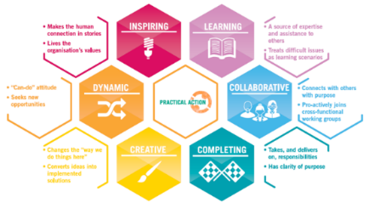

KEY BENEFITS

Hours
A flexi time system is in operation around core attendance times. Full time roles are contracted at 35 hours per week.

Annual leave
Annual holiday entitlement is 25 days in addition to public holidays.

Pension scheme
Practical Action operates an enhanced pension from AEGON. New employees can join the scheme from day one of employment. The employer contributes 10% of salary and the employee contributes 5%.

Bike to Work scheme
Practical Action participates in the Bike to Work scheme. This is a government sponsored initiative designed to encourage bicycle usage as part of their Green Transport Plan. The scheme offers employees a tax advantage that means the cost of buying a bicycle is reduced by 30 to 45%.

Childcare vouchers
Practical Action runs a childcare voucher scheme. Childcare Vouchers cover children up to 16 years of age. They are non-taxable and exempt from National Insurance Contributions.

HOW TO APPLY

Interested applicants should submit their Curriculum Vitae, along with a cover letter outlining their relevant experience and knowledge and day rate, using
https://www.blueoctopus.co.uk/vacancies/vacancy?id=70452 by 30th September 2018.

